MGMS – Project Info View

Functional Specification Document

Ver. 1.4

Version History
Version # | Date | Description
1.0 | 21-Oct-2010 | First draft
1.1 | 24-Nov-2010 | Label changes
1.2 | 26-Nov-2010 | Formula changes

Table of Contents

Version History 2
1 Introduction 4
1.1 Purpose 4
1.2 Scope 4
1.3 Assumptions 5
1.4 Constraints 5
2 Project info 5
2.1 Grant Allocation 6
2.2 Fund Utilization 7
3 Business Rules 8
4 Status Messages 8

Introduction

Purpose

This document provides the requirements and functional specifications for the Project Info page of the Multisite Grant Management System project.
This is not a project plan or a design document. It is a guide for system architecture and development, not for phasing, timelines or deliverables.
Finally, this is a ‘living document’ and the specification will change, continuously, as the project proceeds. More details will be added and the existing information edited as the requirements, scenarios and use cases evolve in the course of the project.

Scope

Once the site administrator/privileged user creates a new project for the institution, the project is displayed in the list of all projects currently active in the institution. The project home page which is opened on selecting the name from the project list, displays the following associated details in a dashboard: grant allocated, total funds received till date, funds utilized for paying for expenses incurred by the project, any funds transferred to other institutions for subprojects and the balance funds remaining in hand.
Also displayed are the project start and end dates alongside the total project duration calculated in number of days. The remaining days till project closure is also calculated and displayed.
Two graphical representations have been provided to give an easy view of grant allocation amongst account heads; and fund utilization with time, respectively.
Future scope envisages a section to summarize the sub project details and more pictorial representations such as the project progress. Further, in future versions, this page will be the Home page for the particular project and all other project pages will be suitably linked to this page for ease of navigation.

Assumptions

- None-

Constraints

The possibility of n levels of sub projects for a project granted to as many different institutions makes it difficult to set a layout which displays the summarized info on a single page. The current version displays up to the first level of sub projects.

Project info

Screen & Control Description

Figure 1: Project Info
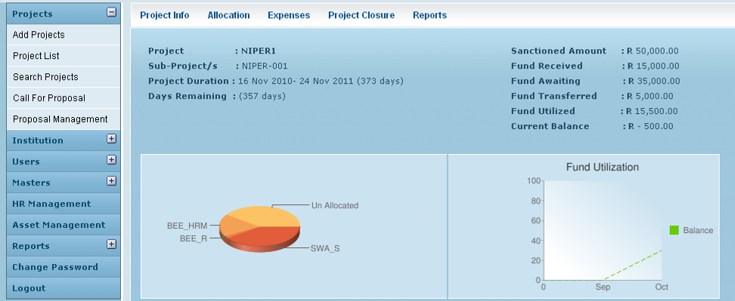

Field /Label | Input-Control | Data Type | Remarks / db table > field
Project | Auto-populated | String
Sub Project/s
Sanctioned Amount | Auto-populated | Number
Fund Received | Auto-populated | Number
Fund Awaited | Auto-populated | Number
Fund Transferred | Auto-populated | Number | sum of all values of fund_transfer>amount
Fund Utilized | Auto-populated | Number | sum of all values of grant_expense> expense_amount
Current Balance | Auto-populated | Number | Fund Received - Fund Transferred - Fund Utilized
Project Duration | Auto-populated | String | difference between the values in projects>project_end_date and projects>project_start_date
Days Remaining | Auto-populated | String | difference between the values in projects>project_end_date and current_date

Two graphical representations have been provided to give an easy view of grant allocation amongst account heads; and fund utilization with time, respectively.

Grant Allocation

The latest saved details of the grant allocation as allocated amongst the various account/sub account heads are displayed as a pie chart. The remaining unallocated fund is also included in the chart.
Distinct colors help distinguish between the various allocations and the size of the each pie indicates the percentage of the total allocation that was allocated to the particular account head.

Pie Chart – Account Headwise Allocation

Chart Component | Value/Requirement | Details
Chart type | 3D pie chart
Chart size (width x height) | 290 x 90 pixels
Chart color (slices) | e25d3a,fb363
Chart background fill solid color | cbe2f 0
Chart area gradient fill at angle 45’ color | cbe2f 0  color centre point is 0  cbe2f 0  color centre point is 1
Chart Title | Fund Allocation
Chart title color, font size | 0000ff,1
Chart data | amounts allocated to different account heads | grant_allocation_split>amount;  (grant_allocation>amount_allocated)-(sum of all grant_allocation_split>amount) should be a data and labeled as “unallocated” amount
Slice Labels | account head names | account_heads>name
Legend position | Legend to the right of the chart, legend entries in a vertical column.

Fund Utilization
This is represented as a line graph with time along the X axis and values 0-100 along the Yaxis, to indicate the percentage of grant allocated that were utilized, across time.

Line Graph – Fund Utilization

Chart Component | Value/Requirement | Details
Chart type | A line chart where data points are spaced evenly along the x-axis. Axis lines are shown by default.
Axes to display | X (bottom) Y(left)
Axis labels to show (X) | X: Months in format – mmm (Start value: month of first expense entry; End value: month of current date)
Axis labels to show (Y) | 0:|0|20|40|60|80|100
Chart size (width x height) | 250 x 180 pixels
Chart color (slices) | 66CC00,3399ff
Chart background fill solid color | cbe2f 0
Chart area gradient fill at angle 45’ color | FFFFFF  color centre point is 0  cbe2f 0  color centre point is 1
Chart Title | Fund Utilization
Chart title color, font size | 0000ff,1
Chart data | (total expenses / total funds allocated) *100 |  | total expenses: sum of all values of:  grant_expense>expense_amount  total funds allocated: sum of all values of grant_allocation_split>amount
Legend position | Legend to the right of the chart, legend entries in a vertical column.

Business Rules
-None-

Status Messages

-None-

